REPUBLIC OF CAMEROON REPUBLIC DU CAMEROUN

Peace-Work-Fatherland Paix-Travail-Patrie

University of Buea Universite de Buea

**FACULTY OF ENGINEERING AND TECHNOLOGY**

**DEPARTMENT OF COMPUTER ENGINEERING**

**CEF440: Internet Programming and Mobile Programming**

Design and Implementation of Mobile-Based Archival and Retrieval of Missing Objects Application using Image Matching

**Academic year 2023/2024**

SUPERVISED BY

**Dr Nkemeni Valery**

**PRESENTED BY MEMBERS OF GROUP 9**

|  |  |
| --- | --- |
| **MATRICLE** | **NAME** |
| FE21A128 | AHOUMO TEMATEU ROXANE PHILIPPINE |
| FE21A152 | BOUCHUKE BABILA DANIEL |
| FE21A166 | DERRICK MBUNBO FORCHA |
| FE21A325 | TIANI PEKINS EBIKA |
| FE21A303 | SAMUEL OSH |

**ACKNOWLEDMENTS**

**A**cknowledging the assistances of DR NKEMENI VALERY the course instructor and an elderly for his marvelous work and knowledge mounted upon me through this years of studies, my team and some close friends for their guidance and care. May the good LORD continues to guide and protect you all .Thanks

**Table of Contents**

**Introduction 7**

**1 REQUIRMENT GATHERING TECHNIQUES 8**

**2 QUANTITATIVE ANALYSIS 9**

**3 DOCUMENTAL ANALYSIS 10**

**4 WHAT TO DO AFTER REQUIRMENT GATHERING 11**

**4.1 Documenting requirements 11**

**II PRACTICE 13**

**6 FUNCTIONAL REQUIRMENTS 15**

**7 NON FUNCTIONAL REQUIRMENTS 16**

**8 BEST PRACTICES FOR DOCUMENTING GATHERED REQUIRMENTS 18**

**CONCLUSIONS 20**

**REFERENCES 21**

Table of figures

Figure 1: Use case diagram for mobile base object archival application. 15

Figure 2: Key types of non-functional requirements 17

## **Introduction**

The evolution of mobile computations and wireless communications technologies has embedded itself in our lives due to its rapid development. Ubiquitous wireless devices used in daily tasks have led to the revolution of Mobile Government (m-Government) systems aiming to deliver services and information anywhere and anytime to citizens through the utilization of mobile technologies and applications. However, only the performance of the delivered services establishes its usefulness with many undiscovered applications to such innovations, especially since this is a desired area for further development with relation to smart cities. One such application is the lost and found items retrieval utility. The loss or misplacement of personal belongings is a common occurrence that can cause inconvenience and distress to individuals. Traditional methods of searching for missing objects, such as posting flyers or contacting lost and found services, are often time-consuming and ineffective. To address this issue, this project proposes the development of a Mobile-Based Archival and Retrieval of Missing Objects Application using Image Matching. This project aims to leverage mobile technology and image matching algorithms to create a robust and user-friendly platform for archiving and retrieving missing objects. The mobile application will allow users to capture images of lost items, store them in a centralized database, and perform real-time image matching to identify potential matches.

### **1 REQUIRMENT GATHERING TECHNIQUES**

These are simply the various ways and methods used to have as much as requirements from the users. This stage can also be known as the **UX RESEARCH Stage,** where a group of **user researchers** use on or two techniques to have some of the requirements that the app need to have.

There are two types of UX research, namely; Quantitative and Qualitative research.

#### Quantitative research

In short, it means collecting and analyzing numerical data to describe characteristics, find corrections; or test hypotheses*.* As a class of requirement gathering, Quantitative analysis mostly deals with collecting data from a very large population. Below are some of the techniques used to carry out Quantitative Research?

1. **Survey**

A survey is a method of gathering information using relevant questions from a sample of people with the aim of understanding population as a whole. Offering a survey or questionnaire allows you to collect information from many people in a relatively short amount of time, particularly helpful for interacting with people in different geographic locations and also good for budget savings and time constraints. When preparing your survey, consider these tips:

* Keep them shorter versus longer so people are more likely to complete them
* Focus on a feature or topic, rather than many at once
* Use ratings to generate data analysis responses, like "strongly agree," "agree" or "disagree"
* Have some open-ended questions to allow free-form responses to get detailed input
* Use the six question words to structure your survey: who, what, when, where, why and how, like "How does the user login," or "Where are the results shown in the program?"

Moreover, the question could be multiple choice, multi-select, text entering, ranking and rating order, and slide-by-slide.

Also, there are two types of survey;

* **Online Survey**

This is the use of softwares to carry out our survey. The best tool we can use here is GOOGLE FORM, which does not only allow us to do form our questionnairs and share using a link, but to gather and arrange responses from users in an organised manner making use of graphs and various charts diagram.

Below is the link to create an online survey on google, **online survey tool**:

<https://docs.google.com/forms/u/0/?tgif=d&ec=asw-forms-hero-goto&pli=1>

* **Onsite Survey**

This is the sharing of physical questionnaires to a group of people and collecting their responds after some period of time. You just have to printout a number of questionnaires, select a research area (a school, hospital, institution) and distribute the questionnaires there.

#### Requirement workshop

Firstly, a Workshop is a collaborative session where stakeholders and business analysts or users work together to elicit, validate, and prioritize requirements for a project or a product.

Generally, researchers will ask participants to attempt a series of assigned tasks, and then observe and record how well they can accomplish those tasks. Their ability to do the things you want them to do informs your next steps—namely, whether to make changes to your design or product or not, and which changes to make.

After the test is done, you’ll gather and analyze data, and then make choices about the best next-steps.

### 2 QUANTITATIVE ANALYSIS

Quantitative analysis is a process of naturalistic inquiry that seeks an in-depth understanding of social phenomena within their natural setting. It focuses on the "why" rather than the "what" of social phenomena and relies on the direct experiences of human beings as meaning-making agents in their everyday lives.

Six common types of qualitative research are **phenomenological, ethnographic, grounded theory, historical, case study, and action research**.

#### Ethnographic Research

Ethnographic research is an approach to data collection and analysis that aims at evaluating and categorizing human experiences through the lens of the participants’ cultural and ethnic backgrounds. Ethnographers observe life as it happens instead of trying to manipulate it in a lab.  Because of the unpredictability of life, ethnographers often find is challenging to nail down their projects in a protocol for the Board to review.  Nevertheless, the Board needs a good explanation of a study in order to approve it.  Helping the Board to understand the parameters of the study, the situations in which the participants will be contacted and will participate, and the risks involved will allow them to approve studies where some flexibility is needed.

Ethnographic research can be further divided into

#### 2.1.1Phenomenological studies

Phenomenological studies, for their part, place major emphasis on the unique experiences of individuals. Phenomenological research focuses primarily on discovering personal thoughts and experience.

There are various methods on collecting data or requirements in Phenomenological research, some of these include;

* **Participant observation**

Observing the preferences and action of the subject or the individual and interacting with them.

* **P-to P Interview**

Here, the interviewer organise a meet up with the user where questions will be asked to the user. The interview will be registered and analysed. Certain parameters such as the user’s first response and the corporal attitudes will be taken into consideration.

#### 2.1.2Grounded Theory Research

Grounded theory is a systematic [qualitative research](https://www.qualtrics.com/experience-management/research/qualitative-research/) method that collects empirical data first, and then creates a theory ‘grounded’ in the results. Grounded research is different from experimental research or scientific inquiry as it does not need a hypothesis theory at the start to verify. Instead, the evolving theory is based on facts and evidence discovered during each stage. Also, grounded research also doesn’t have a preconceived understanding of events or happenings before the qualitative research commences.

Below are the steps involved in grounded theory research;

* Data Planning: The researcher decides what area they’re interested in. In this stage, you’ll also want to create your open-ended initial research questions.
* Data collection and analysis: The researcher collects qualitative data by asking open-ended questions in interviews and surveys, studying historical or archival data, or observing participants and interpreting what is seen. This collected data is transferred into transcripts.
* Data analysis is turned into a final theory: The researcher takes the core categories and themes that they have gathered and integrates them into one central idea (a new theory) using selective code. This final grounded theory concludes the research
* **Contextual Interviews**

Following the subjects and observing them doing their regular activities while also interacting with them.

* **Archival Research**

The researcher digs down existing documents and past research for understanding the requirements. There is no physical contact with the subjects in the case of archival research.

* 1. **Passive Observation** Following the subjects and observing them doing their regular activities without making an interaction. The researcher may take notes, click photographs, or record videos to draw observational inferences.

### **DOCUMENTAL ANALYSIS**

Document analysis includes reviewing the existing system's documentation, like user manuals and instructions. It is helpful particularly for any changeover risk mitigation and you can glean important information that pushes the boundary of establishing new requirements or validating existing ones. It is helpful to have multiple people review the documents and hold a meeting afterwards to compile your insights to make sure nothing gets missed.

### 4 **WHAT TO DO AFTER REQUIRMENT GATHERING**

Once you are done collecting or gathering the requirement proposed by users, stakeholders, and the business team, you need to document your results and confirm the understanding of the requirement collected.

### **4.1 Documenting requirements**

* Once you’ve gathered your project requirements, you need to document them in a concise and well-organized document.
* Requirements of any kind influence the analysis, design, implementation, and test phases directly and indirectly. Requirements documents may also support the change management activities. When requirements change, the requirements document can serve as the basis to analyze the extent to which other parts of the system are influenced. The change effort can thus be estimated.
* Additionally, requirements documents like BRDs or FRDs can be the basis for legal contracts and other type of agreements with vendors and other stakeholders.
* Documenting the requirements can help to quickly overcome legal conflicts between two or more parties.

#### 4.2 **Confirming understanding of requirements**

Once your project requirements are documented, don’t assume that everybody has a shared understanding. Always remember that each person considers the project from his or her individual perspective. You must understand these different perspectives and gather the different requirements to build a complete picture of what the project should achieve.

Also, share those documented requirements with all of the project's stakeholders to ensure everybody is on the same page before the project begins. If anything was skipped or misunderstood, it’s better to know now.

* **USECASE DIAGRAM:**
* A use case diagram is a UML Diagram which help us to organise all the functional requirement of an app after collecting the various requirements from users.
* You can make used of the use case diagram where all the functional requirements are highlighted for the stakeholders and the business team to clearly understand.
* A tool used to design UML DIAGRAMS (use case diagram) is **STARUML.** https://staruml.io/download/ Here is the link to download the software
* **BUILD A PROTOTYPE**
* A prototype is simply the first preliminary output of a project
* You can do a prototype after the collection of data and present it to the various stakeholders for feedback.
* Tool: figma prototypying, use this link to get there <https://www.figma.com/files/recent?fuid=1183258788115296337>
* **UI DESIGN**
* Once you are done with requirement gathering, you can present or propose a low and high fidelity design to the stakeholders. Once these design are validated, you can now come out with the User Interface Design.
* Tool: fluid AI, adobe xb.

### **II PRACTICE**

1. **TOPIC**:

Archival and retrieval of missing objects using image matching algorithm and advanced machine vision.

1. **PROBLEM STATEMENT**

The loss or misplacement of personal belongings is a common occurrence that can cause inconvenience and distress to individuals. Traditional methods of searching for missing objects, such as posting flyers or contacting lost and found services, are often time-consuming and ineffective. To address this issue, there is a need to develop a mobile application that leverages mobile technology and image matching algorithms to create a user-friendly platform for archiving and retrieving missing objects efficiently.

* **GOAL**: The goal is to provide a solution that streamlines the process of locating lost items, enhances accuracy in matching, and promotes community engagement to improve the effectiveness of the search process.

1. **REQUIREMENT GATHERING**

Our presentation will be divided into 3 parts

1. **IDENTIFYING THE STAKEHOLDERS**

* **Definition**: Firstly, a stakeholder are people who brainstorm, analyze, approve or deny project updates. The stakeholders could be end-users, stakeholders, sponsors, managers, developers, testers, regulators,and any other parties who have a stake in the software outcome.
* **How do we identify stakeholders**: the most user technique to identify stakeholders is through **stakeholder analysis?** This is the process of collecting information about any person that will be impacted by (or can impact) your project
* **Our various stakeholders:** our project is going to have 3 stakeholders, who are
* End-users
* The developers
* The testers
* administrator

1. **REQUIREMENT GATHERING**

**Definition**: as explained above, it is the collection of data or requirements from the various stakeholders.

**Requirement gathering techniques used in our projects**: we used 3 requirement gathering techniques throughout this project

* Brainstorming: this involve a group problem-solving technique that involves the spontaneous contribution of ideas from all members of the group.
* Interviews: we carried out a P-To-P (person to person) research technique. We were able to interview 4 different individuals by the help of a prearranged questionnaire made up of 9 questions as follows
* Have you ever misplace an important item? Being it a document or and a personal identity? What was the item?
* If yes, in what circumstance?
* What type of personal belonging do you usually misplace?
* How do you do after realising you misplaced the object? How do you describe the object (what are some of the criteria you emphasize on why describing your objects)
* What are some of the methods do you use to recover the missing property? Are they easy?
* What if you could use your mobile device to recover your missing item?
* What are some of the features you would like to have or see in that app?
* Will you be comfortable uploading the image of your missing item to give the chance to other people to help you look for your stuff?
* Can we keep your contact in other to keep you updated on the evolution of the app?
* Prototyping: a prototype is **a** product built to test ideas and changes until it resembles the final product. This will be carried on later run in the project after having a first a design.

## **6 FUNCTIONAL REQUIRMENTS**

Are product features or functions that developers must implement to enable users to accomplish their tasks. So it’s essential to make them clear both for the development team and the stakeholders. Generally, functional requirements describe system behaviour under specific conditions

* **Use case Diagram:** Below is the use case diagram which summarises the functional requirements.

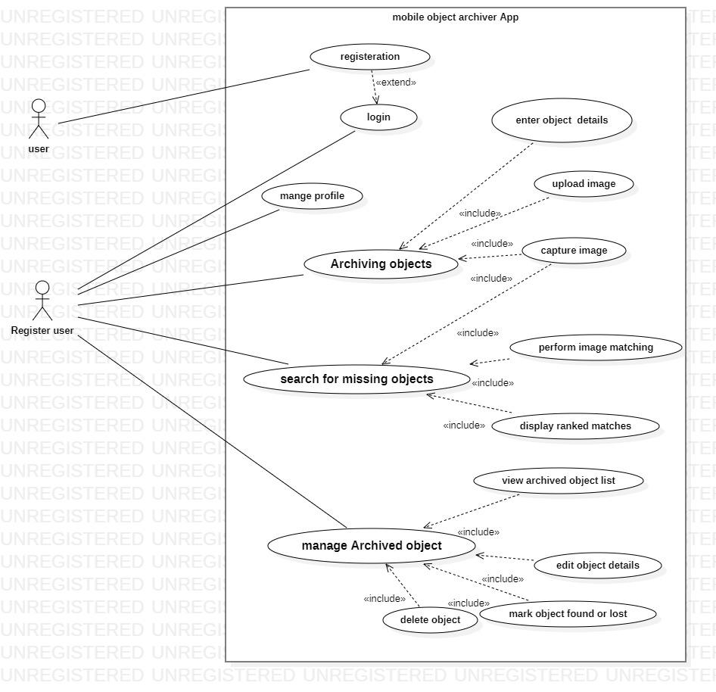

Figure1: Use case diagram for mobile base object archival application.

**Use case specifications**

**I User Management:**

**Register and account creations**

* The app should allow users to create accounts and log in using credentials like email and password or through social media integration

**Authentication**

* Users can log in to their account using their credentials
* Users can manage their profile information (e.g., name, email).

Also the user would be able to

* Capture or upload images of their belongings.
* Search for missing items by capturing a new image or uploading an existing one.
* Users can edit or delete archived object information.
* Users can filter and sort archived objects (e.g., by category, date added).

**Reporting**

* Users can mark an archived object as "found" or "lost."
* Users should also be able to provide feedback or rate services/products within the app.
* The app can send notifications to users for updates, reminders, or promotional content.

**II Object archival**

The preservation and management of digital representations of physical objects.

Here,

* Users can capture images of objects using the device camera.
* Users can upload images of objects from their device gallery.
* Users can add details to archived objects which could be optional.

Example of these added details would include;

* + Name or description of the object.
  + Brand and model Serial number or other unique identifier (if applicable).
  + Purchase receipt information (image or text, optional).

**III Object Retrieval:**

* Users can search for missing objects using a new image captured by the camera.
* Users can search for missing objects by uploading an existing image from the device gallery.
* The search results should display a ranked list of potential matches from the archived database based on image similarity scores.
* Users can view detailed information associated with each matched object in the search results globally

## **7 NON FUNCTIONAL REQUIRMENTS**

Are not related to the system's functionality but rather define how the system should perform. They are crucial for ensuring the system's often influencing the overall experience. Gathering of these requirements could be done by talking to people, conducting workshops, and using surveys etc.

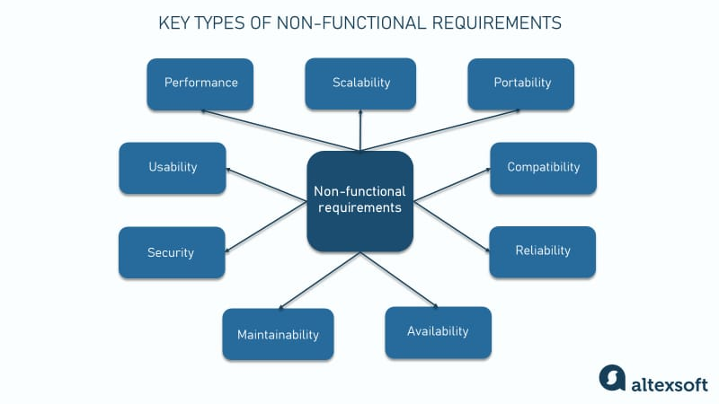

Figure 2: Key types of non-functional requirements

For

1. **Performance:**

* The application should be responsive and perform actions within a reasonable timeframe.

Example,

* + The app should launch quickly on various models of the mobile device.
  + Image capture and upload should be efficient and not take excessive time.
  + Image matching and search results should display within a tolerable wait time.

1. **Availability:**

* The application should be available for use most of the time with an uptime target of about 98% and more.
* Since it is a mobile based application, thus the need for it to function properly even under moderate network conditions (3G/4G).

1. **Security:**

* User credentials must be securely stored using hashing or encryption to prevent unauthorized access.
* User data (object details, images) must be securely stored in the applications database or on the device (with user consent for device storage) using encryption at rest and in transit.
* The application should implement secure communication protocols (HTTPS) for data transmission.
* The application should be regularly tested for vulnerabilities and patched promptly.

1. **Usability:**
   * The user interface should be intuitive and user-friendly for people with varying technical skills

* The application should be accessible for users with disabilities (considerations for visual impairments, etc.).
* The application should be localized to support different languages (if targeting a global audience).

1. **Reliability:**

* The application should function consistently and reliably with minimal crashes or errors.
* Also, the application should recover gracefully from unexpected errors and provide informative feedback to users.

1. **Scalability:**
   * The application should be able to handle an increasing number of users and archived objects without performance degradation.
   * The underlying infrastructure (image stored in the database,) should be scalable to accommodate future growth.
2. **Privacy:**
   * Users should have control over their privacy settings and the data associated with archived objects.
   * The application should collect and store only the data necessary for its functionality and comply with relevant data privacy regulations.
3. **Offline Functionality (Optional):**

The application should allow users to capture images offline and store them locally for upload when an internet connection becomes available.

1. **Battery Consumption:**
   * The application should be energy-efficient and minimize battery drain on mobile devices.
2. **Maintainability:**

* The application code should be well-documented, modular, and easy to maintain for future updates and bug fixes.

These non-functional requirements detail the "how” to address the overall qualities and characteristics of your application. By considering these alongside the Functional requirements detailing the "what" (features) you can ensure a well-rounded mobile application for retrieving and archiving missing objects that provides a positive user experience.

## 8 BEST PRACTICES FOR DOCUMENTING GATHERED REQUIRMENTS

Creating documentation is an integral part of any software development project. Well-documented requirements ensure that stakeholders and developers are on the same page and help define project scope and budget. Here are a few useful tips on how to make great documentation.  
  
 **Gathered Requirements have to be clear and understandable**. Make sure you state requirements concisely, without ambiguity or different interpretations. Also, try to avoid technological jargon. Remember that each audience is different, and stakeholders might not be familiar with specialized tech terminology. Instead, enrich your documents with visuals, diagrams, and graphs to support the information and make it easier to perceive. Adding glossaries and cross-links is also helpful.  
  
**Requirements have to be specific, accurate, and complete.** When writing your documentation, be consistent with the language and make sure that your requirements are accurate. They should cover every scenario but never contradict one another. Avoid vagueness and weak phrases such as “system has to be fast” or “when something happens.” Be specific and quantify the terms so that all the readers can understand them similarly.  
  
**Requirements have to be testable.** Write requirements so that after the product is created, [testing](https://www.altexsoft.com/whitepapers/quality-assurance-quality-control-and-testing-the-basics-of-software-quality-management/) can show whether they are delivered successfully.  
  
**Requirements have to be feasible and sensible**. Focus on the functionality and quality attributes that user’s need. Remember that requirements have to reflect higher-level business objectives.

## 

## **CONCLUSIONS**

By effectively gathering and documenting requirements, a solid groundwork for a successful mobile application is perceived as A clear understanding of user needs, functional and non-functional requirements, and also with the design of the use case diagram to visualize core functionalities, and technical considerations will guide the development process and ultimately lead to a valuable tool for users looking to archive and potentially recover their belongings.

## 

## **REFERENCES**

[1] N. Ghazali and R. Razali, A preliminary review of interface design elements for mobile electronic government systems, In-formation and Communication Technologies (WICT), FourthWorld Congress, pp. 217223, December 2014

[2] T. Alhussain, S. Drew, and O. Alfarraj, Biometric authenti-cation for mobile government security, Intelligent Computing And Intelligent Systems (ICIS) IEEE International Conference,vol.2, pp. 114-118, October 2010.

[3] S. Chan, A. Connell, E. Madrid, P. Dongkuk, and R. Kamoua,RFID for personal asset tracking, Systems, Applications andTechnology Conference, 2009. LISAT 09. IEEE Long Island,pp. 1-7, May 2009.

[4] S. Chutichudet, T. Kanthathasiri, I. Ritsakunchai, and D. Wong-sawang, LFD: Lost and Found Dog application on mobile,Student Project Conference (ICT-ISPC), 2014. Third ICTInternational, March 2014.

[5] H. Bay, T. Tuytelaars, and L. Van Gool, SURF: Speeded UpRobust Features, Computer Vision and Image Understanding,vol.110, Issue 3, pp. 346-359, June 2008

[6]Jamali, H. R. (2018). [Does research using qualitative methods (grounded theory, ethnography, and phenomenology) have more impact?](https://www.sciencedirect.com/science/article/abs/pii/S0740818818300197?via%3Dihub)Library & Information Science Research, 40(3-4), 201-207.

[7] Lützén, K. (2017). [The value of qualitative methods in prioritized healthcare research](https://journals.sagepub.com/doi/10.1177/2057158517745474)*.* Nordic Journal of Nursing Research, 37*(4), 175-176.*

[8] https://www.iiba.org/business-analysis-blogs/requirements-documenting--the-foundation-of-a-projects-success/